Section 8 – Testing

Home Screen:
Test No. | Test Description | Test Type | Data Type | Test Data | Expected Result | Actual Result | Pass/Fail | Screenshot
1 | Home screen loads when program runs | Functional | Typical | Run the application | Home screen window opens with title 'El Aziz', 'Welcome to El Aziz!' header, contact info, Create an Account button, and Login button all visible. | This performs as expected. | Pass | Figure 1
2 | Contact information displayed correctly | Functional | - | - | Contact details shown: elazizservices@gmail.com and +998 93-945-86-91. | This performs as expected. | Pass | Figure 1
3 | Create an Account button opens account creation window | Functional | - | - | Account creation window opens, home screen remains open. | This performs as expected. | Pass | Figure 2
4 | Login button opens login window | Functional | - | Click 'Login' button on home screen | Login window open, home screen remains open | This performs as expected. | Pass | Figure 2
5 | Home screen remains open when child window opens | System | - | Click 'Create an Account'; then click 'Login' | Home screen stays open in the background, multiple windows can be opened independently. | This performs as expected. | Pass | Figure 1
6 | Database and menu initialised on launch | Integration | - | Run application for the first time (no existing database) | create_database() and insert_menu_items() run on startup. ElAziz.db created. | This performs as expected. | Pass | Figure 3
7 | Menu items not duplicated on multiple launches | Integration | - | - | insert_menu_items() inserts 9 menu items into tblMenu. | This performs as expected. | Pass | Figure 1
8 | Home screen window is correct size | Functional | - | - | Window opens at 600x400 pixels as specified. | This performs as expected. | Pass | Figure 1
9 | Full home screen experience | System | Typical | - | Contact information displayed, big heading, and buttons to login or create account displayed. | This performs as expected. | Pass | -

Account Creation:
Test No. | Test Description | Test Type | Data Type | Test Data | Expected Result | Actual Result | Pass/Fail | Screenshot
1 | Submit valid customer account | Functional | Typical | Valid details, role = Customer | Account created successfully, window closes. Record inserted into tblCustomers with CUST prefix ID. | This performs as expected. | Pass | Figure 4
2 | Submit valid Staff account | Functional | Typical | Valid details, role = Staff | Account created successfully, window closes. Record inserted into tblStaff with STAFF prefix ID. | This performs as expected. | Pass | Figure 5
3 | Submit valid Admin account | Functional | Typical | Valid details, role = Admin | Account created successfully, window closes. Record inserted into tblAdmin with ADMIN prefix ID. | This performs as expected. | Pass | Figure 6
4 | Submit with all fields empty | Unit | Extreme | All fields left blank | Error message: 'All fields must be filled in'. No record inserted to account database. | This performs as expected. | Pass | Figure 7
5 | Invalid username length | Unit | Extreme | Username = 'ab' (2 characters)  Username = 'abcdefghijklmnopqrstu' (21 characters) | Error message: 'Username must be between 3 and 20 characters'. | This performs as expected. | Pass | Figure 8
6 | Enter username at minimum and maximum accepted values | Unit | Extreme | Username = e.g ‘ellat123' (8 characters)  or ‘ellathames12345678921’ | Account created, window closes. Entry is within length limit. | This performs as expected. | Pass | -
7 | Invalid password length | Unit | Extreme | Password = 'pass1' (5 characters) | Error message: 'Password must be at least 6 characters'. | This performs as expected. | Pass | Figure 9
8 | Enter password at minimum accepted value | Unit | Extreme | Password = 'pass12' (6 characters) | Account created, window closes. Entry is within length limit. | This performs as expected. | Pass | -
9 | Invalid email format (no @ or . symbol) | Unit | Invalid | Email = 'invalidemail.com' ‘invalid@emailcom’ ‘invalidemailcom’ | Error message: 'Email must be a valid format e.g. name@email.com'. | This performs as expected. | Pass | Figure 10
10 | Invalid phone number type (not integer) | Unit | Invalid | Phone = 'abcdefghijk' | Error message: 'Phone number must contain numbers only'. | This performs as expected. | Pass | Figure 11
11 | Invalid phone number length | Unit | Extreme | Phone = '0123456' (7 digits) | Error message: 'Phone number must be 11 digits'. | This performs as expected. | Pass | Figure 12
12 | Submit without selecting a role | Unit | Invalid | All valid fields entered, but no role checkboxes selected | Error message: 'Please select a role'. No record inserted into role database. | This performs as expected. | Pass | Figure 13
13 | Full Account creation process | System | Typical | All valid details, role selected | Account created, return to home screen. | This performs as expected. | Pass | -

Login:
Test No. | Test Description | Test Type | Data Type | Test Data | Expected Result | Actual Result | Pass/Fail | Screenshot
1 | Login with valid Customer details | Functional | Typical | Username: customer1, Password: pass123 (existing customer account) | Successful login, account found and matched. Customer dashboard opens. Login logged in tblLoginLogs. | This performs as expected. | Pass | Figure 14
2 | Login with valid Staff details | Functional | Typical | Username: staff1, Password: pass123 (existing staff account) | Successful login, account found and matched. Staff dashboard opens. Login logged in tblLoginLogs. | This performs as expected. | Pass | Figure 15
3 | Login with valid Admin details | Functional | Typical | Username: admin1, Password: pass123 (existing admin account) | Successful login, account found and matched. Admin dashboard opens. Login logged in tblLoginLogs. | This performs as expected. | Pass | Figure 16
4 | Login with incorrect password | Functional | Invalid | Username: customer1, Password: wrongpass | Error message: 'Login Failed!' displayed in red. No dashboard opened. | This performs as expected. | Pass | Figure 17
5 | Login with incorrect username | Functional | Invalid | Username: wronguser, Password: password | Error message: 'Login Failed!' displayed in red. No dashboard opened. | This performs as expected. | Pass | Figure 18
6 | Login with both fields empty or one field empty. | Unit | Invalid/ Extreme | Username: Password:  (Empty fields)  Username: customer1, Password: | Error message: 'Login Failed!' displayed in red. No dashboard opened. | This performs as expected. | Pass | Figure 19
7 | Dashboard shows only Customer options for Customer | Integration | Typical | Log in as Customer role | Only Browse Menu, Create Order, Create Reservation, View Orders/Reservations, Manage Account buttons shown. | This performs as expected. | Pass | Figure 14
8 | Dashboard shows only Staff options for Staff | Integration | Typical | Log in as Staff role | Only View Shifts, View Databases, View Orders/Reservations, Manage Account buttons shown. | This performs as expected. | Pass | Figure 15
9 | Dashboard shows only Admin options for Admin | Integration | Typical | Log in as Admin role | Only View All Shifts, View Databases, Order New Stock, Reports & Analytics, Manage Accounts buttons shown. | This performs as expected. | Pass | Figure 16
10 | Back button on login screen closes window | Functional | Typical | Click Back button on login screen | Login window closes; home screen remains open. | This performs as expected. | Pass | -
11 | Full Login process | System | Typical | Valid username and password | Account found, successful login. Open dashboard window. | This performs as expected. | Pass | -

CUSTOMER TASKS:
Browse Menu:
Test No. | Test Description | Test Type | Data Type | Test Data | Expected Result | Actual Result | Pass/Fail | Screenshot
1 | Open ‘Browse Menu’ screen | Functional | Typical | Click ‘Browse Menu’ button on dashboard | Menu screen opens showing all menu items from tblMenu. | This performs as expected. | Pass | Figure 20
2 | Items displayed sorted by price in ascending order | Unit | - | - | Items are sorted from lowest to highest price. Green Tea $1.50 appears first. | This performs as expected. | Pass | Figure 20
3 | Items grouped by category | Functional | - | - | Items organised by Starter, Salad, Drink, Main categories. | This performs as expected. | Pass | Figure 20
4 | Search for an existing item by menu item name | Unit | Typical | Search term = 'Plov' | Result label shows: 'Found: Plov - $6.50 (Main)'. | This doesn’t perform as expected.  Displayed ‘Item not found’, despite the item existing in the tblMenu. I will need to fix the binary search for the menu items, making sure it identifies the item correctly. It may be an error when finding and comparing the menu items to the other tblMenu records, to find search item. | Fail | Figure 21
5 | Search for an item with upper/lower case | Unit | Invalid | Search term = 'plov' or ‘PLOV’ | Result label shows: 'Found: Plov - $6.50 (Main)'. | This doesn’t perform as expected.  Displays ‘Item not found’, despite the actual item existing in tblMenu. I didn’t consider using .lower/upper string methods at the end of entries, when gathering user input. This restricts the performance of the system and can frustrate users. I should add these string methods to improve functionality, increasing customer satisfaction. | Fail | Figure 22
6 | Search for an unavailable item | Unit | Invalid | Search term = 'Pizza' | Result label shows 'Item not found'. | This performs as expected. | Pass | Figure 23
7 | Search with empty search field | Unit | Extreme | Search term = '' (blank) | Result label shows 'Item not found'. | This performs as expected. | Pass | Figure 24
8 | Scrollbar allows viewing all items | Functional | Typical | Open Browse Menu, drag scrollbar | All 9 menu items are visible by scrolling. Scrollbar functions correctly. | This performs as expected. | Pass | Figure 20
9 | All item details are displayed | Integration | - | - | Each item shows name, price, and description pulled correctly from tblMenu. | This performs as expected. | Pass | Figure 20
10 | Back button closes menu screen | Functional | Typical | Click Back button on menu screen | Menu screen closes, dashboard remains open. | This performs as expected. | Pass | -
11 | Cheapest item appears first | Unit | Extreme | - | Green Tea ($1.50) is the first item shown. | This performs as expected. | Pass | Figure 20
12 | Most expensive item appears last | Unit | Extreme | - | Plov ($6.50) is the last item shown. | This performs as expected. | Pass | Figure 20
13 | Full browse menu process | System | Typical | Valid entries | Search item found, go back, and return to dashboard. | This performs as expected. | Pass | -
Create Order:
Test No. | Test Description | Test Type | Data Type | Test Data | Expected Result | Actual Result | Pass/Fail | Screenshot
1 | Open ‘Create Order’ screen | Functional | Typical | Click ‘Create Order’ button on dashboard | Order screen opens. All menu items shown with checkboxes and entry bars to choose quantity. | This performs as expected. | Pass | Figure 25
2 | Select one item with quantity 1 and submit | Functional | Typical | Select 'Plov', quantity = 1 | Order inserted into tblOrders with totalPrice = 6.50, screen closes. | This performs as expected. | Pass | Figure 26
3 | Select multiple items with quantities and submit | Functional | Typical | Select 'Plov' x 1, 'Green Tea' x 2 | Order inserted into tblOrders with correct total 9.50, all items listed in menuItem field. | This performs as expected.  However, it could be improved as the updating of the total price can be confusing. Customers must specify the item quantity before selecting the item for the total to update dynamically, which reduces customer experience and can cause issues. By adjusting the program to allow users to choose item and then specify their quantity, it would make the process a lot easier and smoother. | Pass | Figure 27
4 | Total updates dynamically when item selected | Unit | Typical | Select 'Mantu' x2 | Total label updates to 8.00 quickly without needing to submit. | This performs as expected. | Pass | Figure 28
5 | Total updates when item deselected | Unit | Typical | Select then deselect 'Mantu' | Total returns to 0.00 when item is deselected. | This performs as expected. | Pass | Figure 29
6 | Submit order with no items selected | Functional | Extreme | No checkboxes selected, click Submit Order | Order isn’t submitted. | This doesn’t perform as expected.  The system still submits the order, despite it being empty. This reduces program efficiency and takes up storage space. By adding validation to check the selection via presence checks could prevent this. | Fail | Figure 25
7 | Enter invalid quantity (not integer) | Unit | Invalid | Select 'Mantu'; quantity = 'abc' | Quantity sets to 0 due to try/except. Order not submitted. | This performs as expected. | Pass | Figure 30
8 | Enter quantity of 0 for selected item | Unit | Extreme | Select 'Mantu'; quantity = 0 | Item not included in order, total for item = 0.00, order is not submitted. | This doesn’t perform as expected.  No error message is displayed advising customer to select a quantity between 1 and 5. The order is still submitted, which is a waste of storage space and limits system efficiency. Need to fix the submit_order() subroutine. | Fail | Figure 31
9 | Enter an invalid quantity (extreme value) | Unit | Extreme | Select 'Plov'; quantity = 100 | Error: Quantity must be between 1 and 5. Order not submitted, range checked. | This doesn’t perform as expected.  No error message displayed advising customers to enter quantity between 1 and 5. Submits the order with the total set at 0.0. Need to fix the submit_order() subroutine. | Fail | Figure 32
10 | CustomerID is correctly stored with order | Integration | Typical | Submit order as logged-in customer | tblOrders record contains the correct customerID (roleID) for that customer. | This performs as expected. | Pass | Figure 33
11 | Back button closes order screen | Functional | Typical | Click Back button on order screen | Order screen closes, dashboard remains open. | This performs as expected. | Pass | -
12 | Submit valid order | Functional | Typical | Specify quantity, select item. | Order successfully created, inserted into tblOrders. Window closes, return to dashboard. | This performs as expected. | Pass | -
13 | Full create order process | System | Typical | Valid entries and selections. | Order successfully created, inserted into tblOrders. Window closes, return to dashboard. | This performs as expected. | Pass | -
Create Reservation:
Test No. | Test Description | Test Type | Data Type | Test Data | Expected Result | Actual Result | Pass/Fail | Screenshot
1 | Open ‘Create Reservation’ window | Functional | Typical | Click ‘Create Reservation’ button on dashboard | Reservation screen opens. All entry bars shown to complete. | This performs as expected. | Pass | Figure 34
2 | Submit a valid reservation | Functional | Typical | Date=15/06/2026, Time=19:00, Guests=4, Special=None | Reservation inserted into tblReservations, screen closes, return to dashboard. | This performs as expected. | Pass | Figure 35
3 | Submit with special request included | Functional | Typical | Date=20/06/2026, Time=18:00, Guests=2, Special=Window seat | Reservation stored with special request text in specialRequest field. | This performs as expected. | Pass | Figure 36
4 | Submit with one of date, time and number of guests fields empty | Unit | Invalid/ Extreme | Date= , Time=19:00, Guests=2 or time blank or guests blank.  All fields empty. | Error: 'Date, time and guests must be filled in' displayed in red. | This performs as expected. | Pass | Figure 37
5 | Enter date in wrong format (no / ) | Unit | Invalid | Date=15062026 | Error: 'Date must be in format DD/MM/YYYY' displayed in red. | This performs as expected. | Pass | Figure 38
6 | Enter time in wrong format (no : ) | Unit | Invalid | Time=1800 | Error: 'Time must be in format HH:MM' displayed in red. | This performs as expected. | Pass | Figure 39
7 | Enter invalid number of guests (not integer) | Unit | Invalid | Guests=four | Error: 'Number of guests must be a number' displayed in red. | This performs as expected.  However, this could be improved by removing the previous error message, replacing it with the new and current error message. The repeated red error messages can overwhelm and confuse the user, so by dynamically updating it to fit the current situation, it would increase system efficiency and make it more user friendly. | Pass | Figure 40
8 | Enter minimum and maximum accepted values of guest. | Unit | Extreme | Guests=1  Guests=20 | Reservation accepted; boundary value 1/20 passes range check. | This performs as expected. | Pass | Figure 41
9 | Enter invalid number of guests (exceeds limit) | Unit | Extreme | Guests=0  Guests= 21 | Error: 'Number of guests must be between 1 and 20' displayed in red. | This performs as expected. | Pass | Figure 42
10 | Back button closes reservation screen | Functional | Typical | Click Back on reservation screen | Screen closes, dashboard remains open. | This performs as expected. | Pass | -
11 | Full create reservation process | System | Typical | All valid entries, submit reservation | Reservation successfully created, screen closes, and dashboard remains open. | This performs as expected. | Pass | -

View Orders/ Reservations:
Test No. | Test Description | Test Type | Data Type | Test Data | Expected Result | Actual Result | Pass/Fail | Screenshot
1 | Open ‘View Orders & Reservations’ screen | Functional | Typical | Click ‘View Orders/Reservations’ on dashboard | View screen opens, only orders and reservations belonging to logged-in customer are shown. | This performs as expected. | Pass | Figure 43
2 | Only customer's own orders/ reservations displayed | Integration | - | - | Only reservations and orders with matching customerID are displayed. | This performs as expected. | Pass | Figure 43
3 | Orders are sorted by total price ascending | Unit | - | - | Orders displayed in ascending price order. | This performs as expected. | Pass | Figure 43
4 | Reservations are sorted by date | Unit | - | - | Reservations displayed in ascending date order. | This performs as expected. | Pass | Figure 43
5 | Search for an order by valid order ID | Unit | Typical | Enter existing orderID in search box, click Search | Result label shows order ID, items and total price. | This doesn’t perform as expected.  It displays ‘Order not found’ despite its existing and being valid. I typed it in correctly and can see it on the list, however the search cannot return the correct result or present the correct label. I will need to fix the binary search labelling under the if statements, or resolve the binary search algorithm as a whole. | Fail | Figure 44
6 | Search for an order by an invalid order ID | Unit | Invalid | Enter orderID = 9999 (not in database), click Search | Result label shows 'Order not found'. | This performs as expected. | Pass | Figure 45
7 | Search with empty search box | Unit | Extreme | Leave search field empty, click Search | Result label shows 'Order/ Reservation not found'. | This doesn’t perform as expected.  Despite it still presenting customers with an error message, it only displayed ‘reservation not found’ not including order. This can be fixed by updating the label displayed to include the term ‘Order’. | Pass/Fail | Figure 46
8 | Customer with no orders sees nothing | Functional | - | - | Listbox shows 'No orders found' under Orders section. | This performs as expected. | Pass | Figure 47
9 | Customer with no reservations sees nothing | Functional | - | - | Listbox shows 'No reservations found' under Reservations section. | This performs as expected. | Pass | Figure 47
10 | All order fields displayed correctly | Integration | - | - | Order ID, items, and total ($) are all displayed for each order. | This performs as expected. | Pass | Figure 43
11 | All reservation fields displayed correctly | Integration | - | - | Reservation ID, date, time, guests, and special request all displayed. | This performs as expected. | Pass | Figure 43
12 | Back button closes the view screen | Functional | Typical | Click Back on view orders/reservations screen | Screen closes, dashboard remains open. | This performs as expected. | Pass | -
13 | Full view orders/reservations process | System | Typical | - | Customers view orders/reservations, click back button and return to dashboard. | This performs as expected. | Pass | -
14 | Search for reservation by valid reservation ID | Unit | Typical | reservationID = 5 | Result label shows “Reservation found” | This doesn’t perform as expected.  Displays ‘reservation not found’ when the reservation ID exists, and is in the tblReservations. Need to fix linear search when comparing the search item to the reservation ID. . | Fail | Figure 48
15 | Search for reservation by invalid reservation ID | Unit | Invalid | reservationID= 9999 | Result label shows “Reservation not found” | This performs as expected. | Pass | Figure 48

Manage Account:
Test No. | Test Description | Test Type | Data Type | Test Data | Expected Result | Actual Result | Pass/Fail | Screenshot
1 | Open ‘Manage Account’ screen | Functional | Typical | Click ‘Manage Account’ on dashboard | Account screen opens showing the customer's details. | This performs as expected. | Pass | Figure 49
2 | Correct customer data displayed | Integration | Typical | Log in as Customer | Screen shows customer ID, first name, surname, email, phone, and username from tblCustomers. | This performs as expected. | Pass | Figure 49
3 | CustomerID format is correct | Unit | - | - | ID starts with 'CUST' prefix followed by calculated number. | This performs as expected. | Pass | Figure 49
4 | Password is not displayed on account screen | Functional | - | - | Password field is not shown on the account screen. | This performs as expected. | Pass | Figure 49
5 | Back button closes account screen | Functional | Typical | Click Back on account screen | Account screen closes, dashboard remains open | This performs as expected. | Pass | -
7 | Full manage account process | System | Typical | - | View account details, press back and return to dashboard. | This performs as expected. | Pass | -

STAFF TASKS:
View Shifts:
Test No. | Test Description | Test Type | Data Type | Test Data | Expected Result | Actual Result | Pass/Fail | Screenshot
1 | Open ‘View Shifts’ screen | Functional | Typical | Click ‘View Shifts’ on dashboard | Shifts screen opens. At least one shift shown for logged-in staff member. | This performs as expected. | Pass | Figure 50
2 | Shift already inserted if none exist | Integration | Typical | 02/04/2026, 09:00–17:00, 8 hours | System inserts shift, displayed on screen to show how it would look. | This performs as expected. | Pass | Figure 50
3 | Only shifts for logged-in staff are shown | Unit | - | - | Only shifts where staffID matches roleID are displayed. | This performs as expected. | Pass | Figure 50
4 | Shift details displayed correctly | Integration | - | - | Shift ID, date, start time, end time, and hours are all shown | This performs as expected. | Pass | Figure 50
5 | No shifts message displayed when none exist | Functional | - | - | Label 'No shifts found' is displayed on screen | This doesn’t perform as expected.  Doesn’t show this because the shift is automatically inserted for all staff members. To improve this, I could’ve inserted multiple shift records for different and random staff ID’s. That way, when the staff logged in, some would be shown their shifts and some wouldn’t, which they would expect ‘No shifts found’ to be displayed. | Fail | Figure 50
6 | Back button closes shifts screen | Functional | Typical | Click Back on shifts screen | Shifts screen closes, staff dashboard remains open | This performs as expected. | Pass | -
7 | Full view shifts process | System | Typical | - | Shift details shown, click back to return to dashboard. | This performs as expected. | Pass | -
View Databases:
Test No. | Test Description | Test Type | Data Type | Test Data | Expected Result | Actual Result | Pass/Fail | Screenshot
1 | Open ‘View Databases’ screen | Functional | Typical | Click ‘View Databases’ on dashboard | Database screen opens, 5 tables displayed: tblOrders, tblReservations, tblMenu, tblShifts, tblStock. | This performs as expected. | Pass | Figure 51
2 | All 5 tables are shown | Integration | - | - | Each table name appears as a header followed by its records in the listbox. | This performs as expected. | Pass | Figure 51
3 | tblMenu data visible | Integration | - | - | All 9 menu item records from tblMenu are visible in the list. | This performs as expected. | Pass | Figure 51
4 | tblOrders data visible | Integration | - | - | Order records appear under tblOrders section. | This performs as expected. | Pass | Figure 51
5 | tblReservations data visible | Integration | - | - | Reservation records appear under tblReservations section. | This performs as expected. | Pass | Figure 51
6 | Empty table shows section header with no rows | Functional | - | - | tblStock header shown; no rows beneath it. | This performs as expected. | Pass | Figure 51
7 | Scrollbar allows viewing all data | Functional | - | - | Scrollbar works, all records visible by scrolling. | This performs as expected. | Pass | Figure 51
8 | Staff cannot see customer personal data | System | - | - | tblCustomers, tblStaff, tblAdmin, tblPayments, tblReports, tblLoginLogs are not shown. | This performs as expected. | Pass | Figure 51
9 | Back button closes database screen | Functional | Typical | Click Back on database screen | Database screen closes, staff dashboard remains open | This performs as expected. | Pass | -
10 | Full view databases process | System | Typical |  | 5 database tables displayed relevant to staff role, click back to return to dashboard. | This performs as expected. | Pass | -

View Orders & Reservations:
Test No. | Test Description | Test Type | Data Type | Test Data | Expected Result | Actual Result | Pass/Fail | Screenshot
1 | Open ‘View Orders & Reservations’ screen | Functional | Typical | Click ‘View Orders/Reservations’ on dashboard | Active orders screen opens. All orders and all reservations displayed. | This performs as expected. | Pass | Figure 52
2 | All orders displayed | System | - | - | All orders from all customers shown in the orders section. | This performs as expected. | Pass | Figure 52
3 | Orders sorted by orderDate ascending | Unit | - | - | Orders displayed in ascending date order (currency). | This performs as expected. | Pass | Figure 52
4 | All reservations displayed | System | - | - | All reservations shown in the reservations section. | This performs as expected. | Pass | Figure 52
5 | Order details shown correctly | Integration | Typical | Orders exist in tblOrders | Order ID, customer ID, items, and total price all displayed for each order. | This performs as expected. | Pass | Figure 52
6 | Reservation details shown correctly | Integration | Typical | Reservations exist in tblReservations | Reservation ID, customer ID, date, time, and number of guests shown. | This performs as expected. | Pass | Figure 52
7 | Empty orders section shows correct label | Functional | Typical | No orders exist in tblOrders | Label 'No orders found' shown in orders section. | This performs as expected. | Pass | Figure 52
8 | Empty reservations section shows correct label | Functional | Typical | No reservations exist in tblReservations | Label 'No reservations found' shown in reservations section. | This performs as expected. | Pass | Figure 52
9 | Back button closes active orders screen | Functional | Typical | Click Back on active orders screen | Screen closes, staff dashboard remains open. | This performs as expected. | Pass | -
10 | Full view orders & reservations process | System | Typical | - | All orders and reservations displayed, sorted by date and time. Click back to return to dashboard. | This performs as expected.  Could be optimised, by implementing a binary search to handle order and reservation searching, especially during peak times where the number of orders and reservations increase. At times of high demand, staff will have to scroll or search for items. The window doesn’t include a scroll bar or listbox, which makes this unsuitable for larger volumes of orders and reservations. By implementing the scroll bar and listbox, this would reduce staff workload and overall optimise the system. | Pass | -
Manage Account:
Test No. | Test Description | Test Type | Data Type | Test Data | Expected Result | Actual Result | Pass/Fail | Screenshot
1 | Open ‘Manage Account’ screen. | Functional | Typical | Click ‘Manage Account’ on dashboard. | Account screen opens showing the staff member's details. | This performs as expected. | Pass | Figure 53
2 | Correct staff data displayed | Integration | - | - | ID, first name, surname, email, phone, and username shown from tblStaff. | This performs as expected. | Pass | Figure 53
3 | StaffID format is correct | Unit | - | - | ID starts with 'STAFF' prefix. | This performs as expected. | Pass | Figure 53
4 | Password not shown on account screen | Functional | - | - | Password field is not displayed. | This performs as expected. | Pass | Figure 53
5 | Back button closes account screen | Functional | Typical | Click Back on account screen | Account screen closes, staff dashboard remains open. | This performs as expected. | Pass | -
6 | Full manage account process | System | Typical | - | Staff account details displayed, click back to return to dashboard. | This performs as expected. | Pass | -

ADMIN TASKS:
View All Shifts:
Test No. | Test Description | Test Type | Data Type | Test Data | Expected Result | Actual Result | Pass/Fail | Screenshot
1 | Open ‘View All Shifts’ screen | Functional | Typical | Click ‘View All Shifts’ on dashboard | Shifts screen opens showing every shift for every staff member. | This performs as expected. | Pass | Figure 54
2 | All staff shifts displayed | System | - | - | All shifts regardless of staffID are shown. | This performs as expected. | Pass | Figure 54
3 | Shift details displayed correctly | Integration | - | - | Shift ID, Staff ID, date, start/end time, and hours shown for each shift. | This performs as expected. | Pass | Figure 54
4 | No shifts found message when table empty | Functional | - | - | Label 'No shifts found' displayed. | This doesn’t perform as expected.  The staff shifts were automatically inserted for display purposes, therefore they are not a real representation. Since they are automatically inserted, there is no chance for them to be empty, unless insert command is removed. To improve this, I could’ve inserted multiple shifts per staff, leaving some staff without shifts. That way, I could’ve viewed both perspectives, hoping to see shifts and some ‘No shifts found’ messages. | Fail | Figure 54
5 | Back button closes shifts screen | Functional | Typical | Click Back on admin shifts screen | Screen closes, admin dashboard remains open, | This performs as expected. | Pass | -
6 | Full view shifts process | System | Typical | - | Admin views all staff shifts, click back to return to dashboard. | This performs as expected. | Pass | -

View Databases:
Test No. | Test Description | Test Type | Data Type | Test Data | Expected Result | Actual Result | Pass/Fail | Screenshot
1 | Open ‘View Databases’ screen | Functional | Typical | Click ‘View Databases’ on dashboard | Databases screen opens, all 11 tables visible. | This performs as expected. | Pass | Figure 55
2 | All 11 tables are displayed | System | - | - | tblCustomers, tblStaff, tblAdmin, tblOrders, tblReservations, tblMenu, tblShifts, tblStock, tblPayments, tblReports, tblLoginLogs all shown. | This performs as expected. | Pass | Figure 55
3 | tblCustomers data visible to admin | Integration | - | - | Customer records displayed under tblCustomers. | This performs as expected. | Pass | Figure 55
4 | tblLoginLogs data visible to admin | Integration | - | - | Login log records shown under tblLoginLogs. | This performs as expected. | Pass | Figure 55
5 | tblAdmin data visible | Integration | - | - | Admin records displayed under tblAdmin section. | This performs as expected. | Pass | Figure 55
6 | Empty table shows header with no rows | Functional | - | - | tblReports header shown with no data rows beneath. | This performs as expected. | Pass | Figure 55
7 | Scrollbar functions for large dataset | Functional | - | - | All data accessible and visible via scrollbar in listbox. | This performs as expected. | Pass | Figure 55
8 | Back button closes all databases screen | Functional | Typical | Click Back on all databases screen | Screen closes, admin dashboard remains open. | This performs as expected. | Pass | -
9 | Full view databases process | System | Typical | - | All databases displayed in listbox with scroll bar, click back to return to dashboard. | This performs as expected. | Pass | -

Order New Stock:
Test No. | Test Description | Test Type | Data Type | Test Data | Expected Result | Actual Result | Pass/Fail | Screenshot
1 | Open ‘Order New Stock’ screen | Functional | Typical | Click ‘Order New Stock’ on dashboard | Order New Stock screen opens. | This performs as expected. | Pass | Figure 56
2 | Feature coming soon message displayed | Functional | - | - | Label 'Feature coming soon' is shown. No form of input present. | This performs as expected. | Pass | Figure 56
3 | Back button closes stock screen | Functional | Typical | Click Back on order new stock screen | Screen closes, admin dashboard remains open. | This performs as expected. | Pass | -
4 | Full order new stock process | System | - | - | Unfinished – would’ve expected stock database to sort data, alert levels and allow admin to order more. | This performs as expected for its display.  However, it failed in the sense it did not fulfill its objectives. It doesn’t present the stock database records, it doesn’t sort these in descending orders, alerting admin of low levels. It also doesn’t allow them to order new stock specifying quantities and displaying total costs. | Pass  (Fail) | -

Reports & Analytics:
Test No. | Test Description | Test Type | Data Type | Test Data | Expected Result | Actual Result | Pass/Fail | Screenshot
1 | Open ‘Reports & Analytics’ screen | Functional | Typical | Click ‘Reports & Analytics’ on dashboard | Reports & Analytics screen opens. | This performs as expected. | Pass | Figure 57
2 | Feature coming soon message displayed | Functional | - | - | Label 'Feature coming soon' is shown. No form of input present. | This performs as expected. | Pass | Figure 57
3 | Back button closes stock screen | Functional | Typical | Click Back on order new stock screen | Screen closes, admin dashboard remains open. | This performs as expected. | Pass | -
4 | Full reports & analytics process | System | - | - | Unfinished – would’ve expected to see graphs/chart, most popular item, profit, number of sales etc. | This performs as expected for its display.  However, it failed In the sense it did not fulfill its objectives. It doesn’t present the graphs or charts for the sales of El Aziz. It doesn’t produce reports of their annual sales, profits, most popular items. It doesn’t include setting to change the time period for the data representations. | Pass  (Fail) | -

Manage Accounts:
Test No. | Test Description | Test Type | Data Type | Test Data | Expected Result | Actual Result | Pass/Fail | Screenshot
1 | Open ‘Manage Accounts’ screen | Functional | Typical | Click ‘Manage Accounts’ on dashboard | Manage accounts screen opens, all user accounts visible. | This performs as expected. | Pass | Figure 58
2 | All customers listed under Customers section | Integration | - | - | All customer records shown under '* Customers' heading. | This performs as expected. | Pass | Figure 58
3 | All staff listed under Staff section | Integration | - | - | All staff records shown under '* Staff' heading. | This performs as expected. | Pass | Figure 58
4 | All admins listed under Admins section | Integration | - | - | All admin records shown under '* Admins' heading. | This performs as expected. | Pass | Figure 58
5 | Account details shown correctly | Integration | - | - | ID, full name, email, phone, and username displayed for each account. | This performs as expected. | Pass | Figure 58
6 | Passwords not visible in manage accounts | System | - | - | Password is not displayed in the listbox entries. | This performs as expected. | Pass | Figure 58
7 | Empty customer table shows section with no rows | Functional | - | - | Customer’s section header shown, no rows beneath. | This performs as expected. | Pass | Figure 58
8 | Scrollbar allows viewing all accounts | Functional | - | - | Scrollbar functions, all records visible by scrolling. | This performs as expected. | Pass | Figure 58
9 | Back button closes manage accounts screen | Functional | Typical | Click Back on manage accounts screen | Screen closes, admin dashboard remains open, | This performs as expected. | Pass | -
10 | Full manage accounts process | System | - | - | All created accounts displayed in listbox, click back to return to dashboard. | This performs as expected.  However, it could be optimised by implementing a search (preferably a binary search) to manage and find user accounts when needed. It would be quicker and more efficient especially if the number of accounts will likely grow, so instead of scrolling, you can search by their ID to find. | Pass | -

Screenshots:
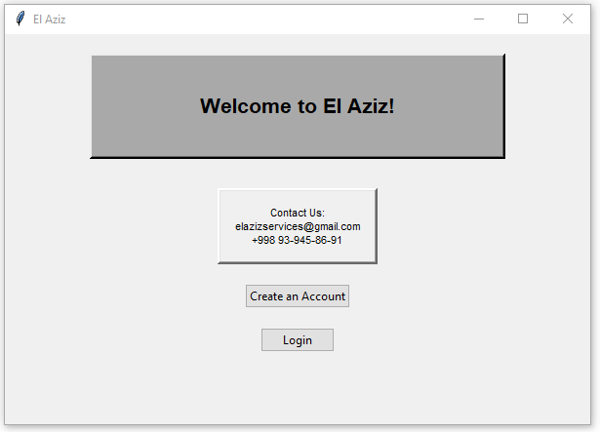
Figure 1

Figure 2
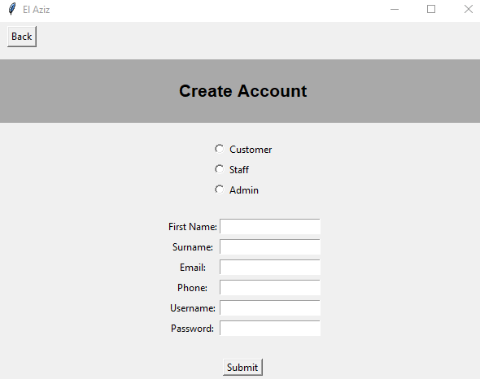
Figure 3
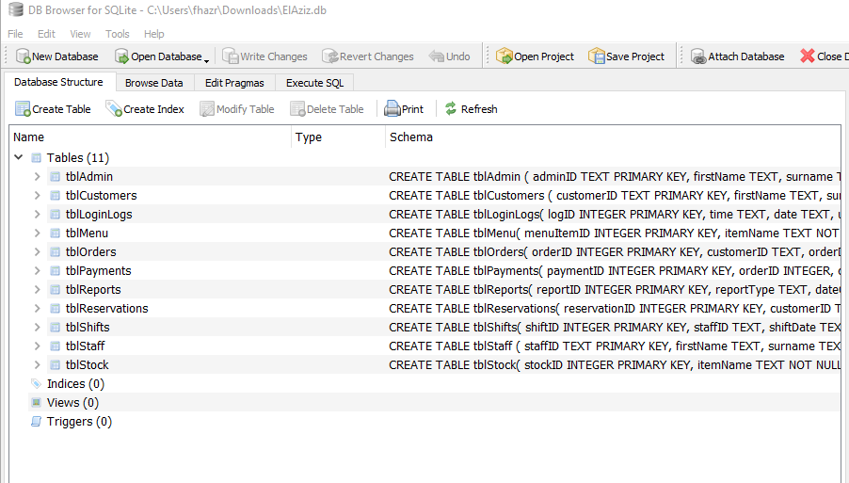

Figure 4
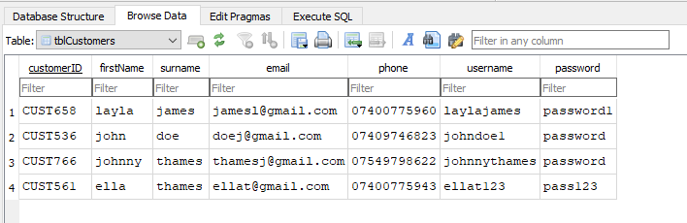
Figure 5
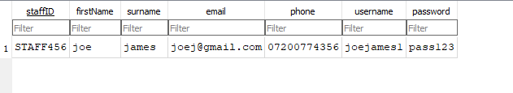
Figure 6
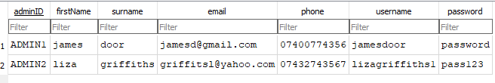
Figure 7
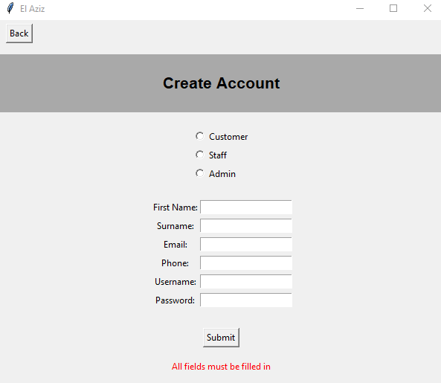
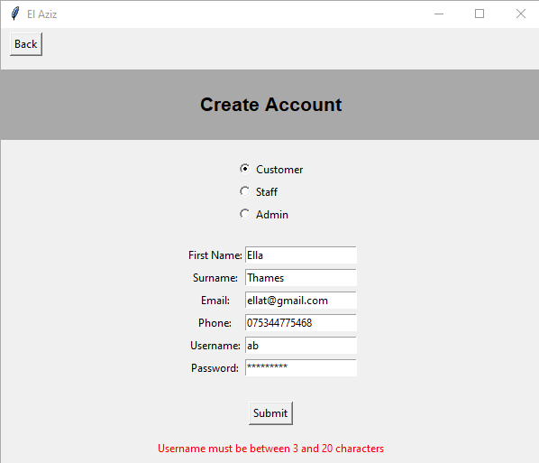
Figure 8

Figure 8

Figure 9
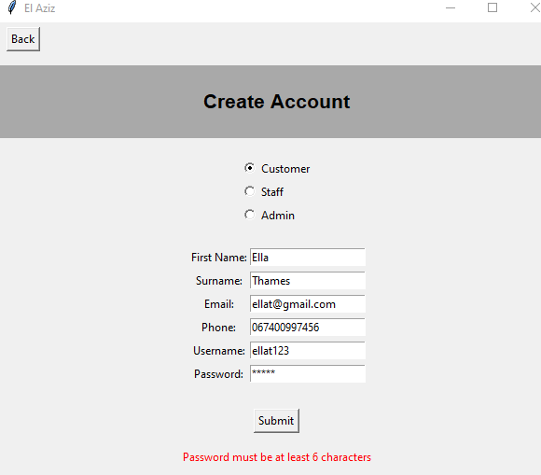
Figure 10
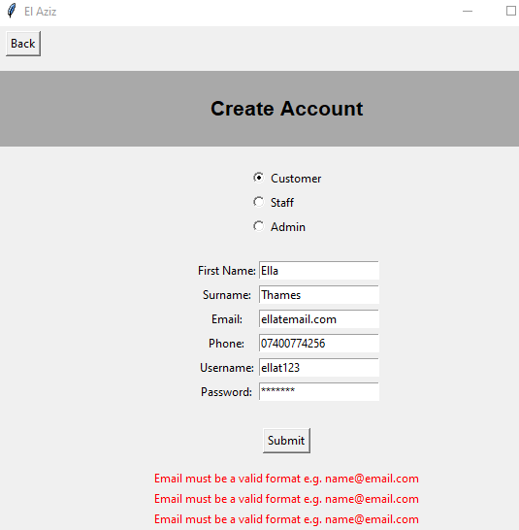
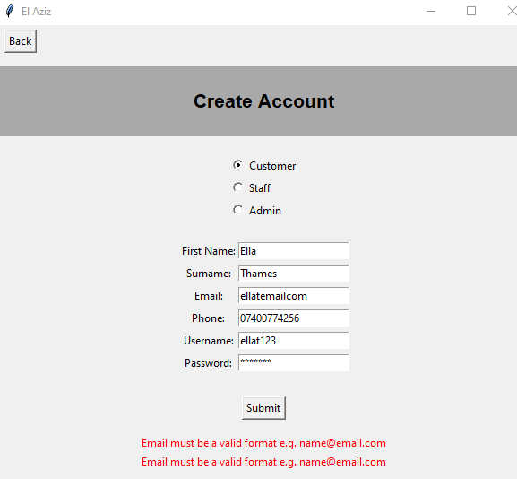
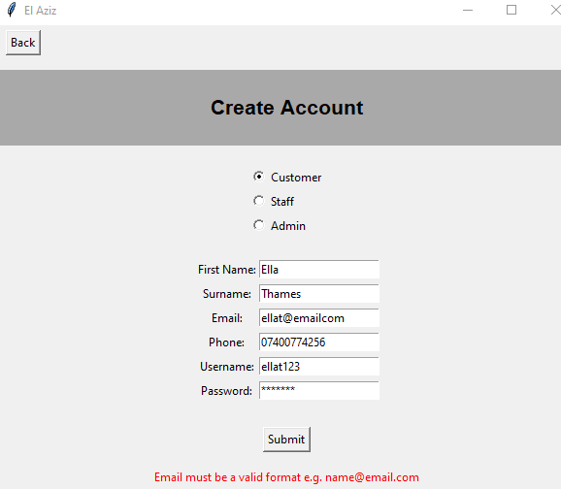

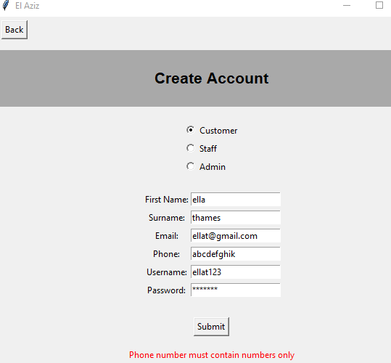
Figure 11

Figure 12
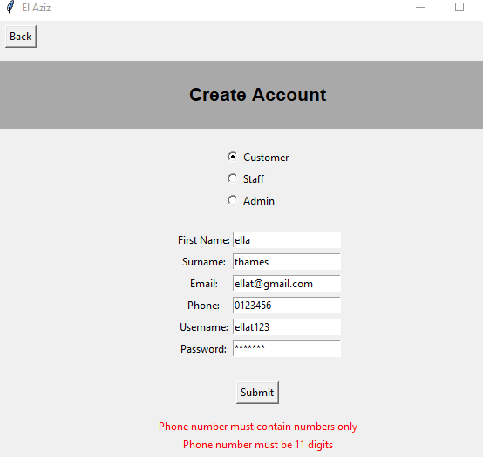
Figure 13
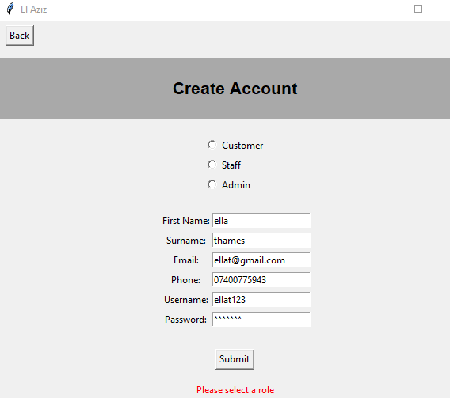
Figure 14
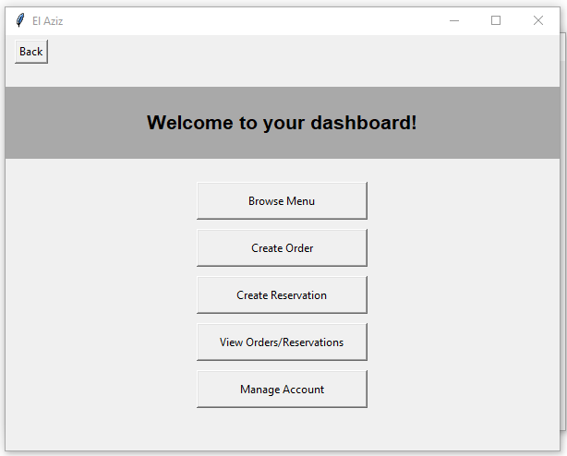
Figure 15
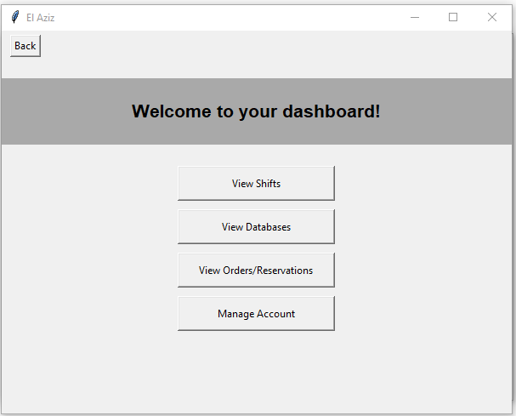
Figure 16
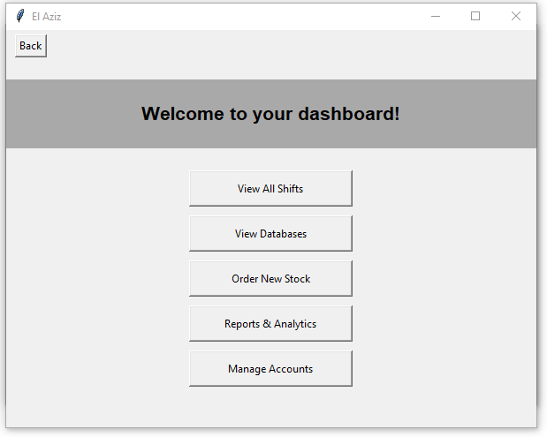

Figure 17
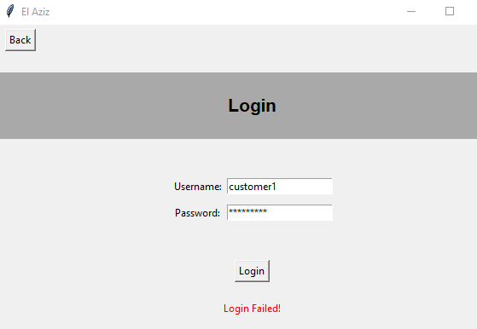
Figure 18
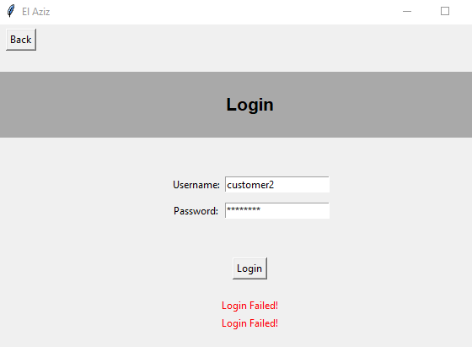

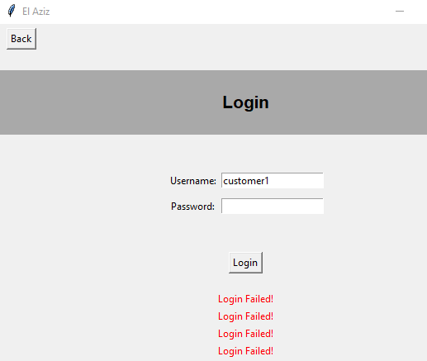
Figure 19
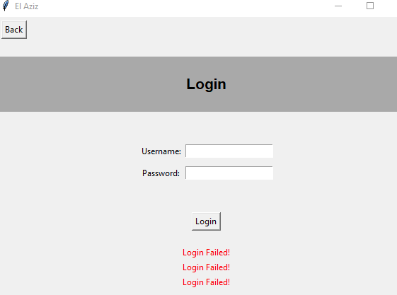

Figure 20
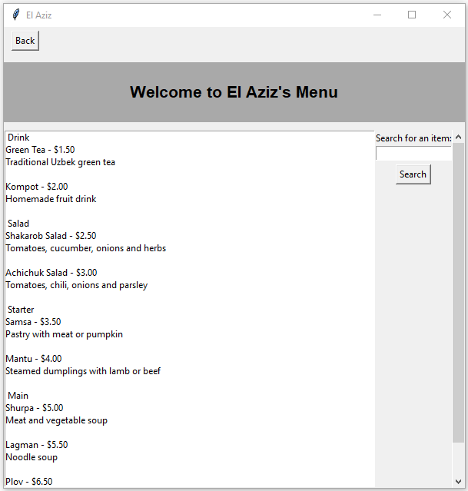
Figure 21
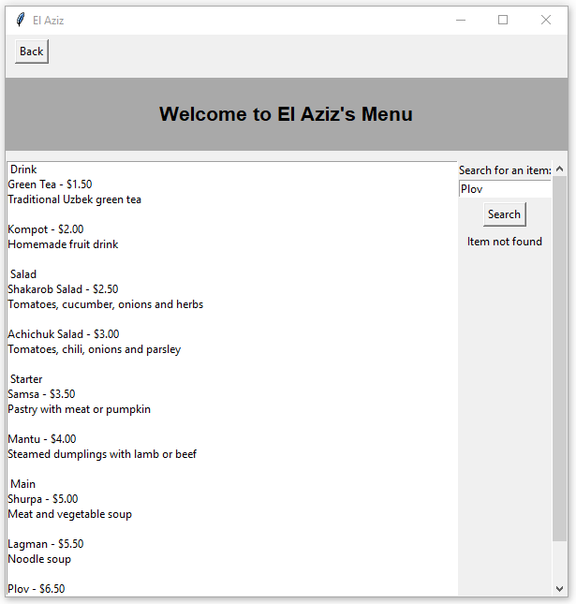

Figure 22
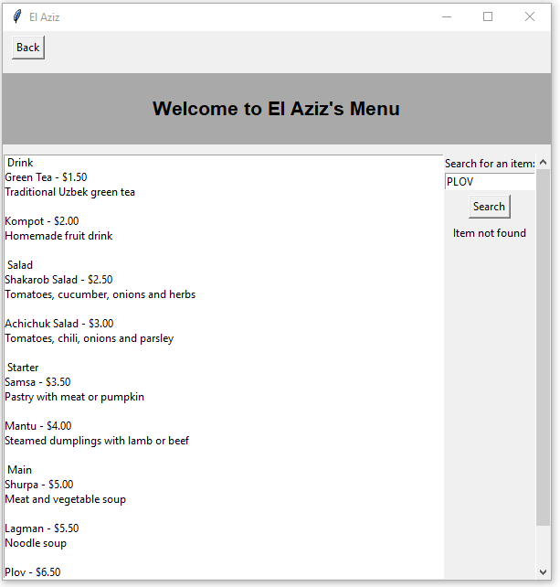
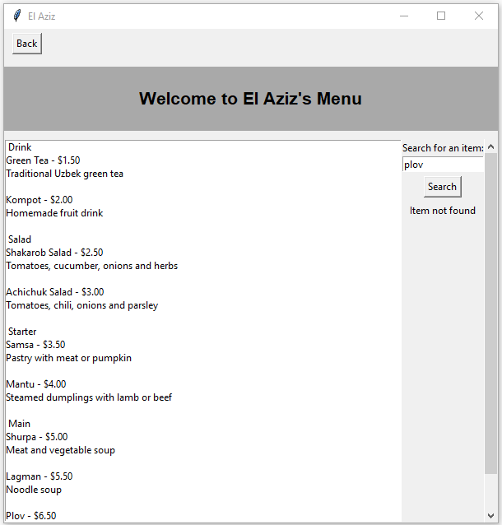
Figure 23
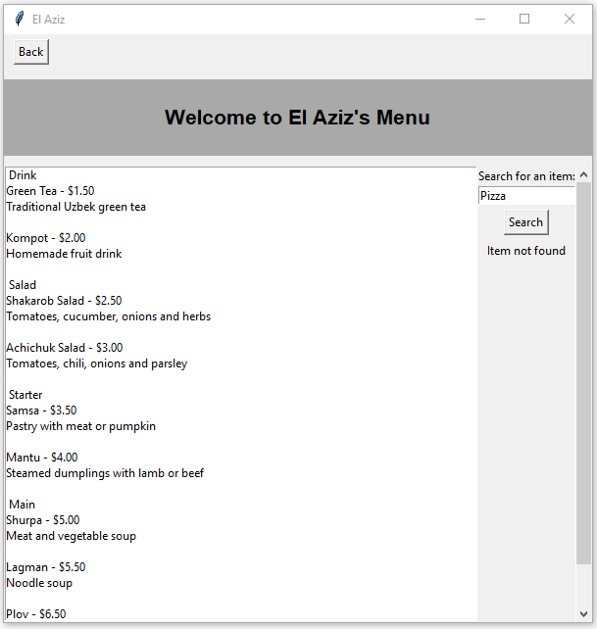

Figure 24
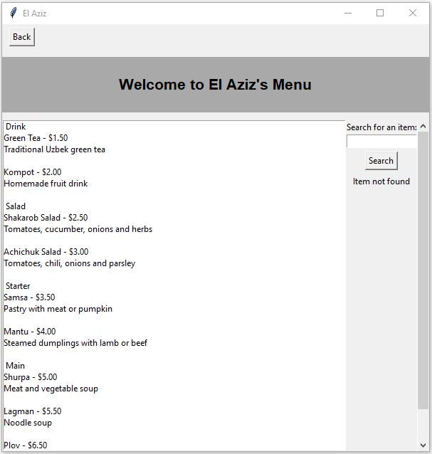
Figure 25
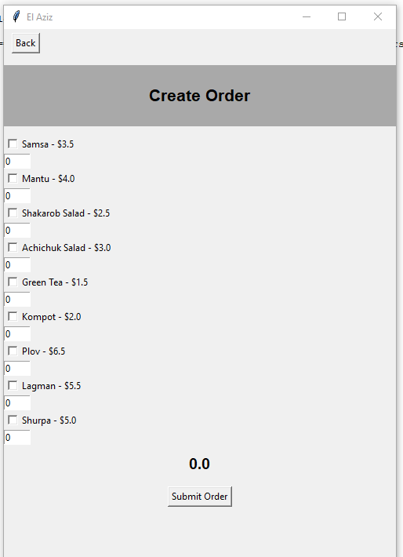

Figure 26
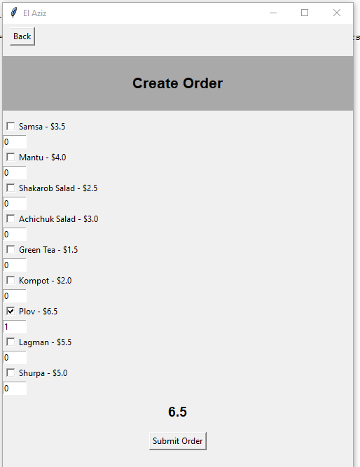
Figure 27
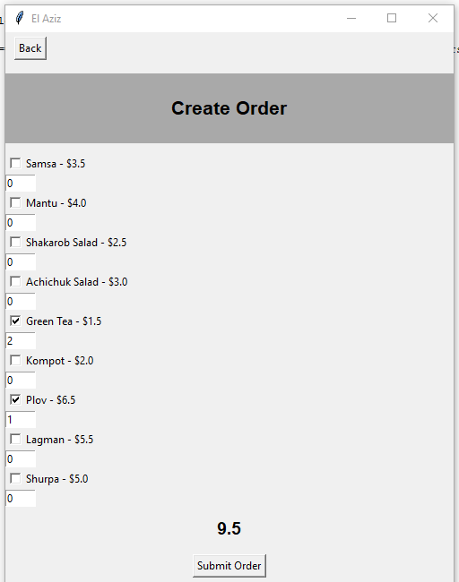

Figure 28
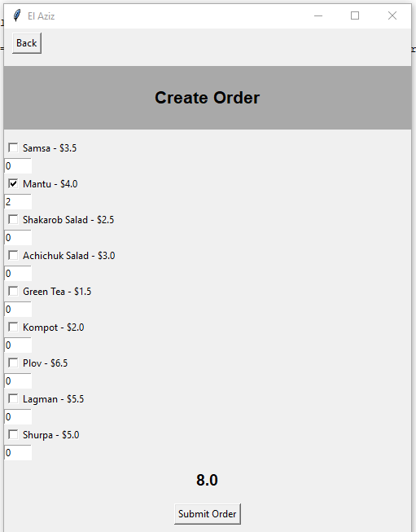
Figure 29
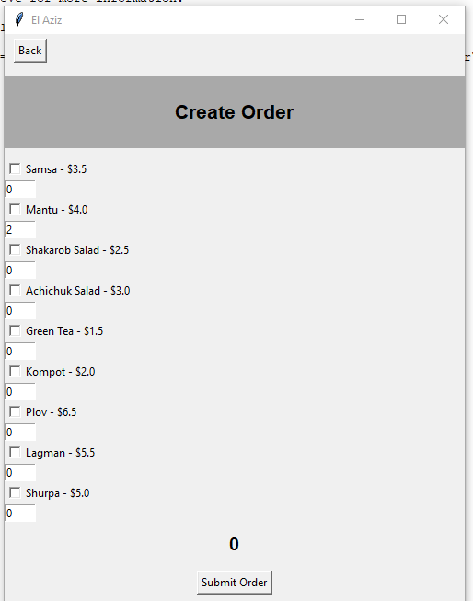

Figure 30
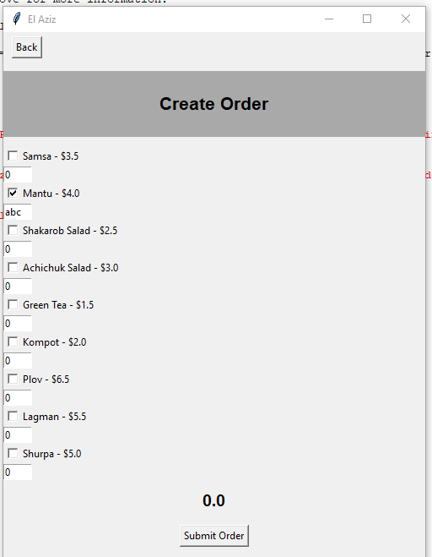
Figure 31
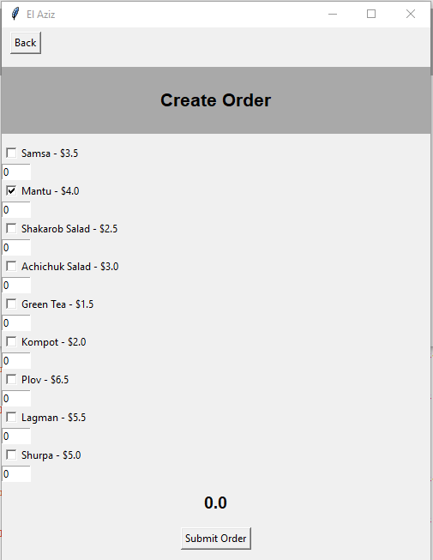

Figure 32
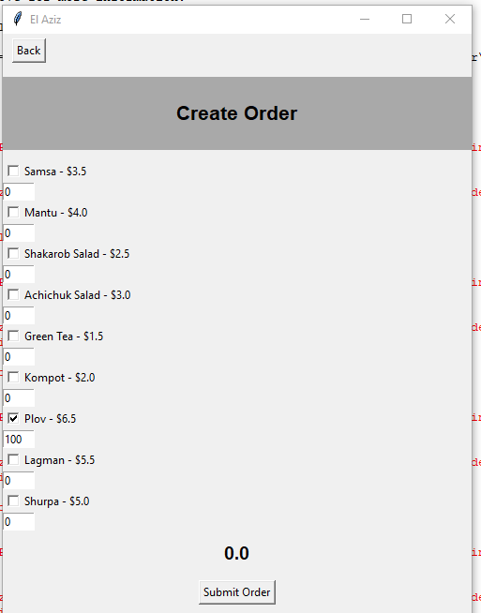
Figure 33
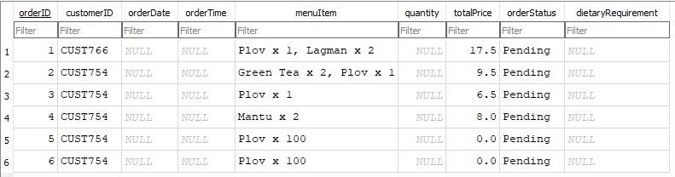
Figure 34
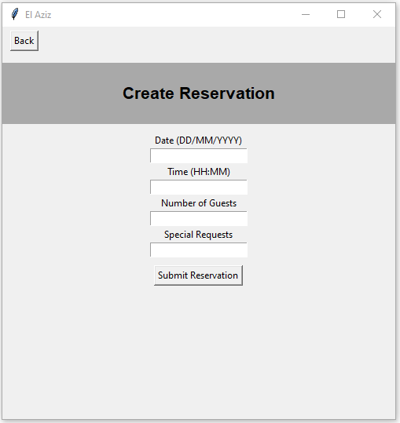
Figure 35
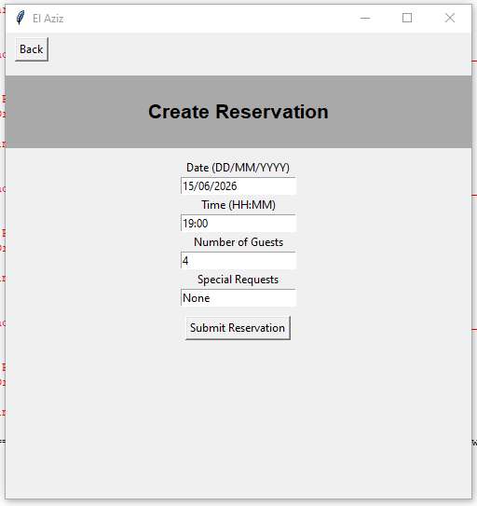
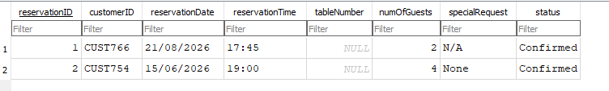
Figure 36
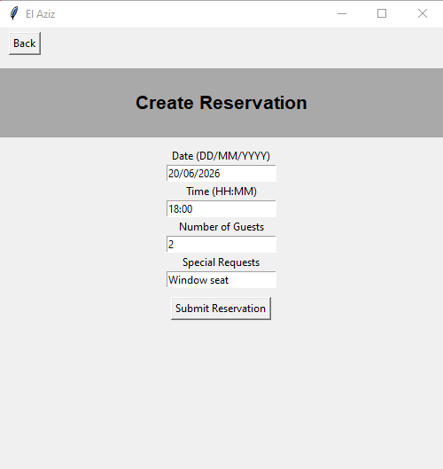
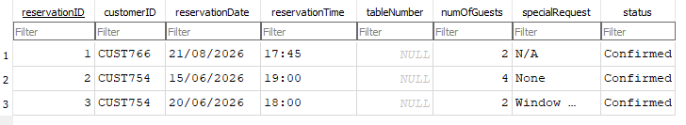

Figure 37
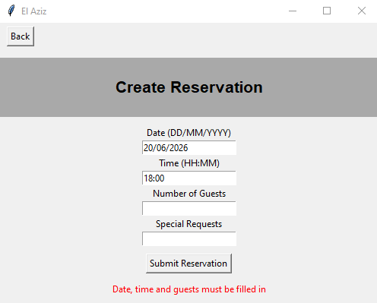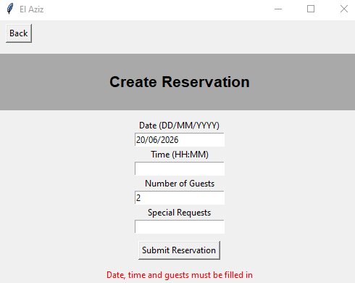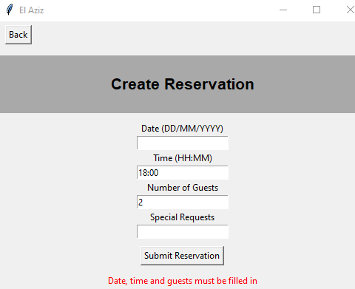
Figure 38
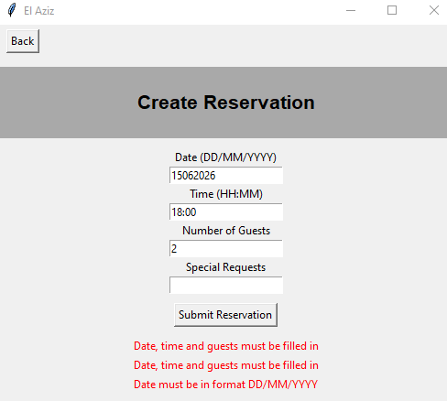

Figure 39
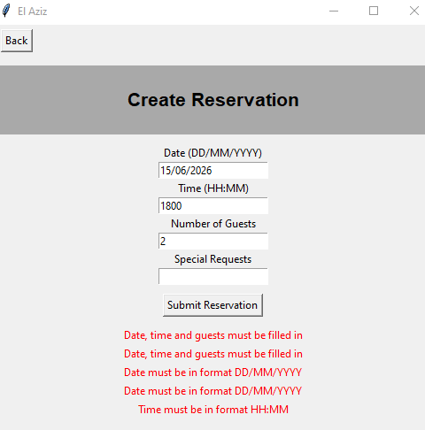
Figure 40
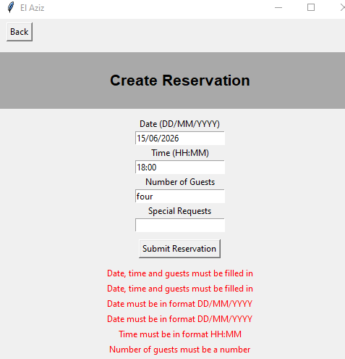
Figure 41

Figure 42
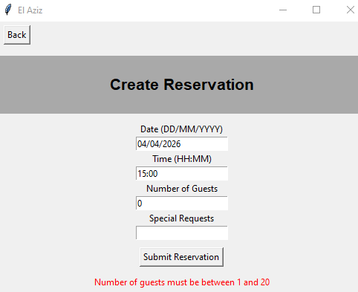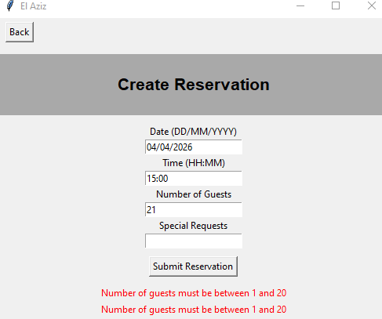
Figure 43
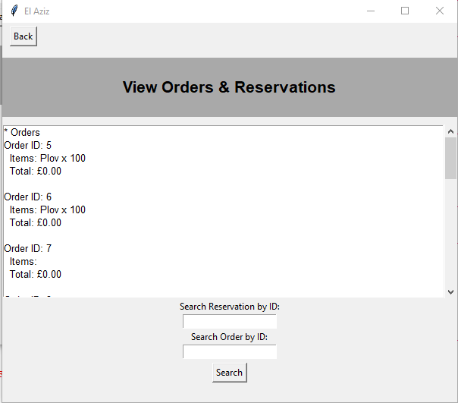
Figure 44
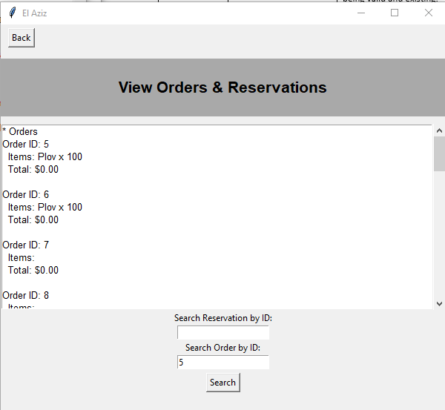
Figure 45
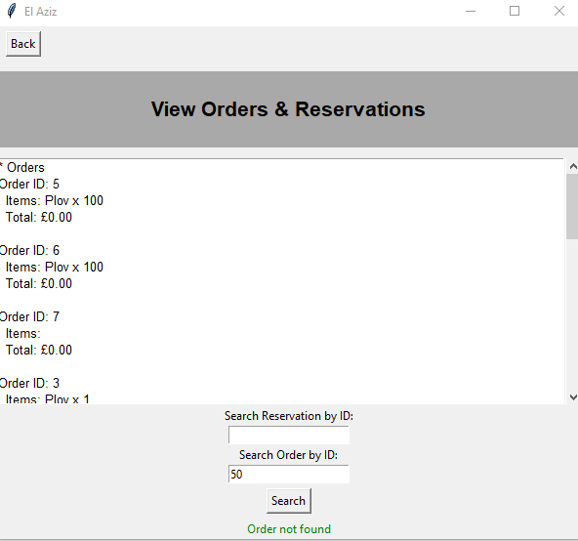
Figure 46
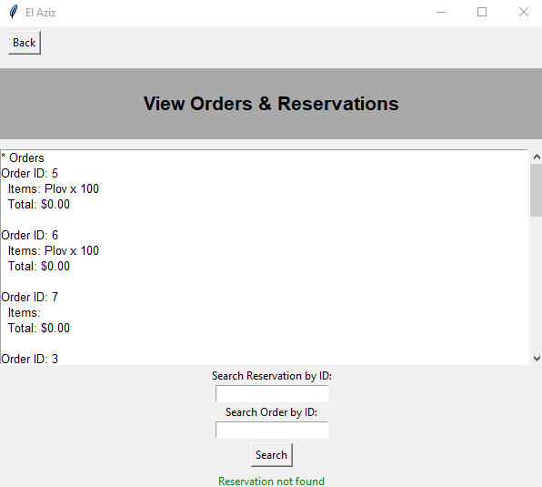
Figure 47
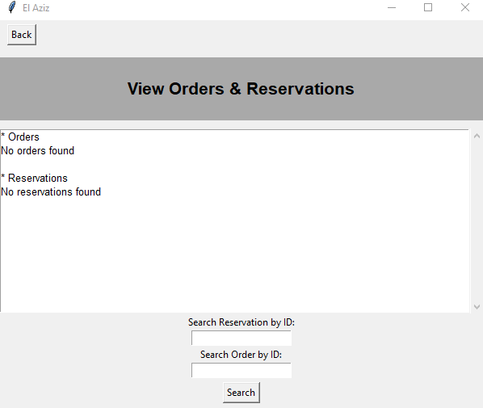
Figure 48
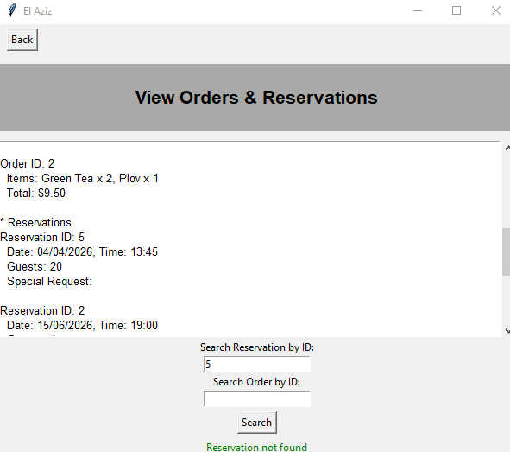
Figure 49
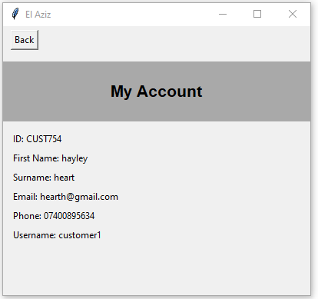
Figure 50
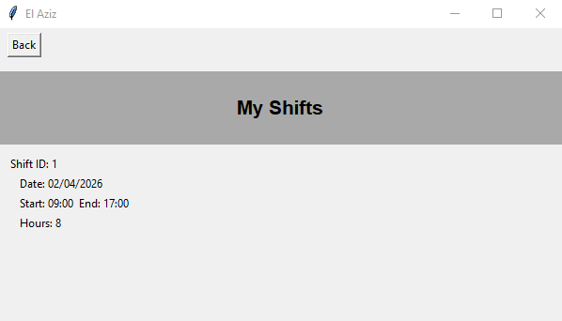

Figure 51
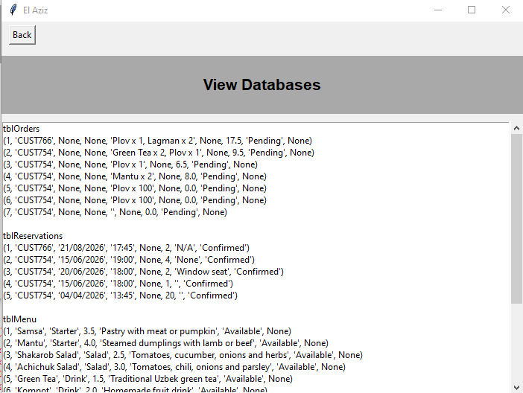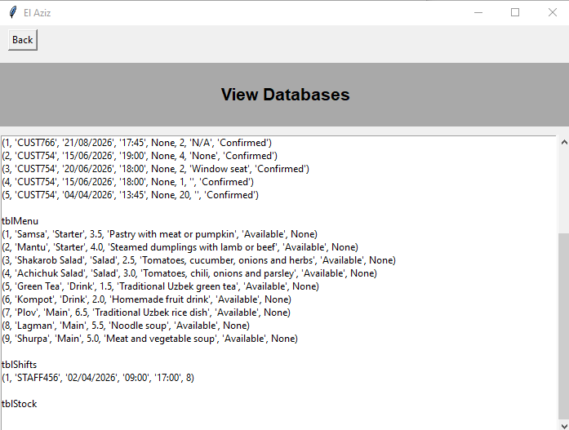

Figure 52
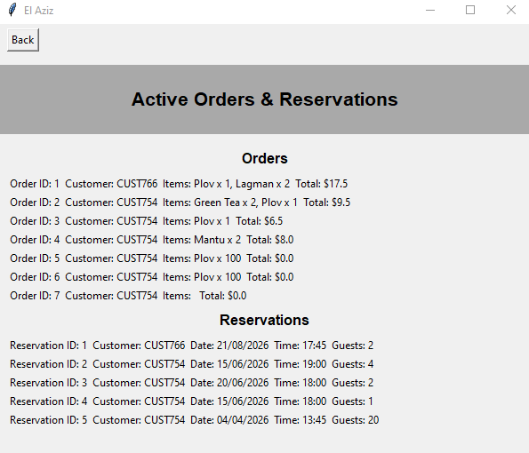
Figure 53
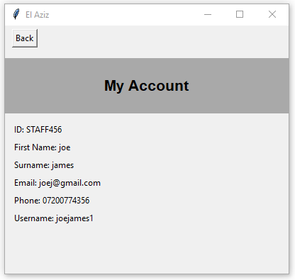

Figure 54
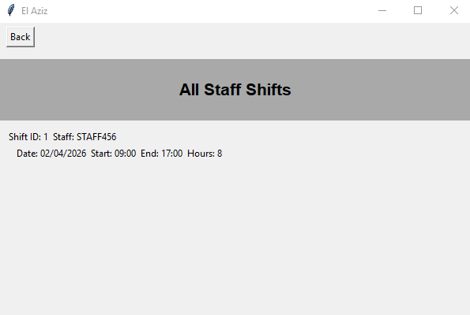
Figure 55
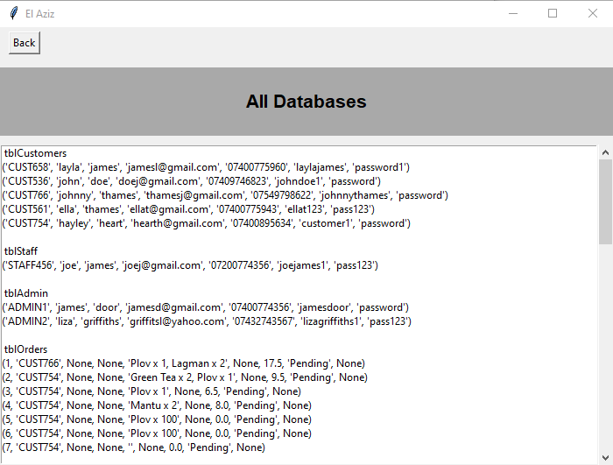
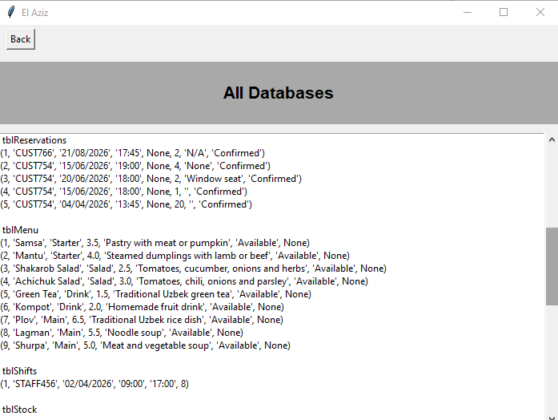

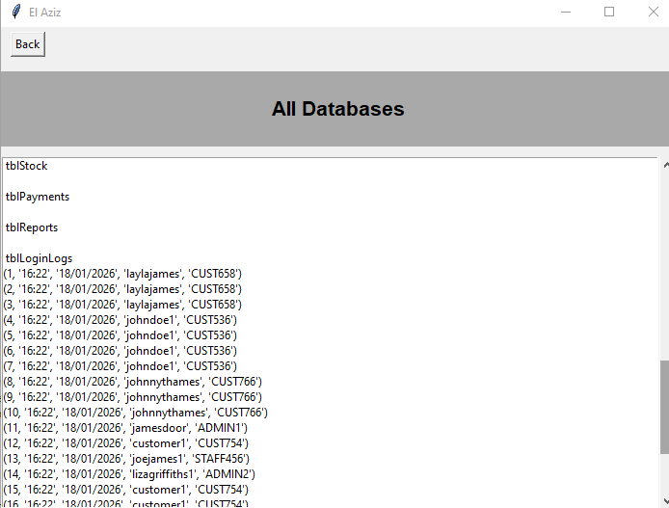
Figure 56
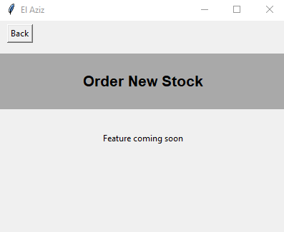
Figure 57
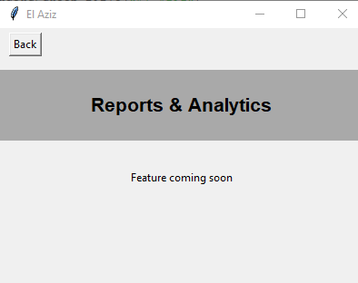
Figure 58
